Intensive B, Session 3: FHA’s Loss Mitigation Waterfall

Problem 1:

Hal Homeowner fell behind on his mortgage loan in June when he lost his job. He has lived in his home for five years, and he got the mortgage at issue to purchase the property. He has never had a loan modification and has never had a partial claim.

At the time of default, Hal’s balance is $92,149.73. Hal’s monthly mortgage payment on the loan at the time of default was $800.00/month and $552.20 toward principal and interest and $247.80/month in escrow. The interest rate of Hal’s loan is 5.25%.

After five months, Hal finally got a new job that pays him a $3,000/month salary. An estimate of the past due amount of arrears, not counting principal balance, are $3,500. Hal has applied for loss mitigation and wants to know what option he will receive and an estimate of what his payment would be.

At the time Hal completes his application for loss mitigation, the market interest rate is 3.75.

What option will Hal receive? Can you estimate his payment?

Problem 2

Bonnie Borrower also lost her job soon after buying her home and has struggled to find a job and finally found one that pays $1550/month. She has never had a partial claim or a loan modification.

Bonnie had a very low interest rate of 3.5% when she bought her house that she still lives in. Bonnie now owes $49,040.45 and pays $375/month on the mortgage ($224.52 for principal and interest and $150.48/month for escrow).

Bonnie is very behind on this loan owing approximately $4,500 in arrears ($5,500 if you count in balance). The market interest rate is 3.5% when she completes her application

What option will she receive? Can you estimate her payment?

Below are some tools

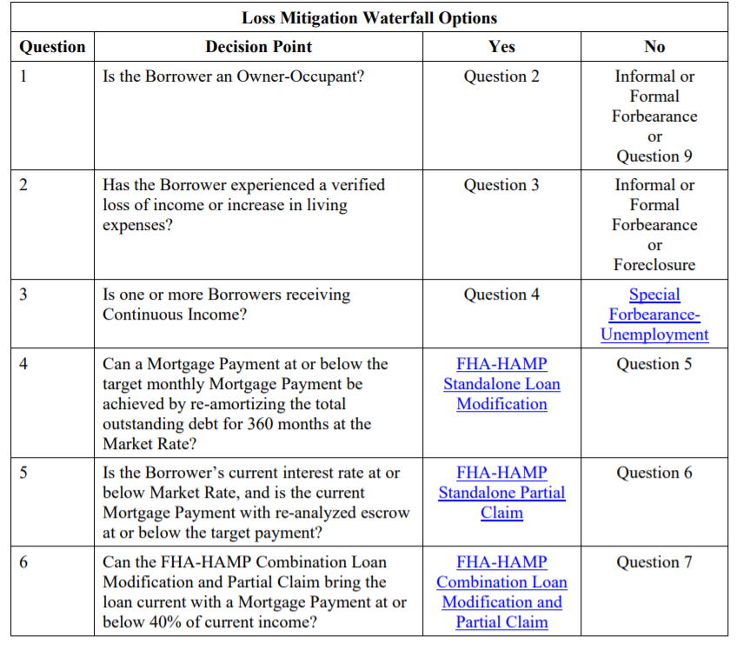
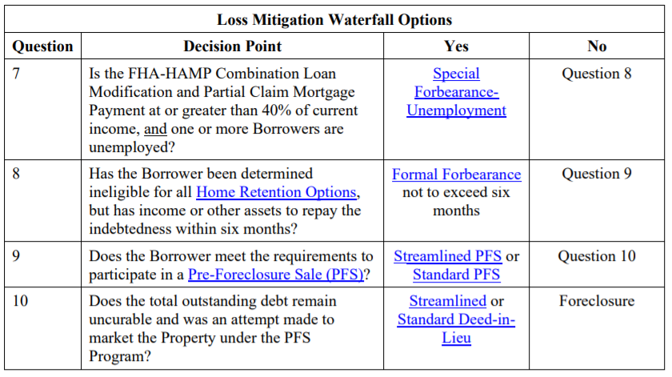
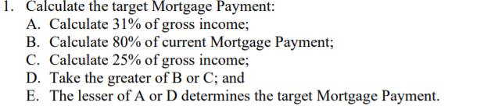

Here’s a sample calculator: https://bretwhissel.net/amortization/

